MINISTRY OF EDUCATION AND SCIENCE OF UKRAINE

NATIONAL TECHNICAL UNIVERSITY

“KHARKOV POLYTECHNICAL INSTITUTE”

LABORATORY WORK № 4

" Use of Arrays and Pointers"

Created by student of 1.КН.201.8г

Chukwu Irele Omike

Checked by

LUTENKO I.V

KHARKIV 2018

Laboratory Training 4

Use of Arrays and Pointers

1 Training Assignment

1.1 Sum of the Minimum and Maximum Items

Write a program that calculates the sum of the minimum and maximum items of an array of double precision floating point values. Use two separate functions.

1.2 Descending Order

Write a program that sorts items of an array of integers in descending order.

1.3 Sum of Positive Items

Write a program that calculates the sum of positive elements of a two-dimensional array.

1.4 Array in Free Store

Write a program that reads from keyboard the size of a two-dimensional array, allocates an array in free store, reads array items from keyboard, calculates sums of rows and puts these sums into a new array.

1.5 Individual Assignment

You should create a program that defines and initializes a two-dimensional array of integer elements and then implements following activities:

transformation of the source array according to step one of the individual assignment

creation and filling of a new (one-dimensional) array of double precision floating point type elements according to step two of the individual assignment

output of both array items

You should create one-dimensional array in free store (heap) using new operator and remove it before end of execution using delete operator. The program should signal errors if transformation or filling are not possible.

Task 1 : The code

#include<iostream>

using namespace std;

double maxint(double arr[], double eleman)

{

static double maxindex,i;

maxindex = arr[0];

for (int i = 0; i < eleman; i++)

{

if (maxindex < arr[i])

maxindex = arr[i];

}

return maxindex;

}

double minint(double arr[], double eleman) {

static double minindex, i;

minindex = arr[0];

for (int i = 0; i < eleman; i++)

{

if (minindex > arr[i])

minindex = arr[i];

}

return minindex;

}

int main() {

double arr[100], i, eleman,sum;

cout << "Enter the number of elements of the array:" << endl;

cin >> eleman;

cout << "Enter the numbers" << endl;

for (int i = 0; i < eleman; i++)

{

cin >> arr[i];

}

maxint(arr, eleman);

minint(arr, eleman);

sum = maxint(arr, eleman) + minint(arr, eleman);

cout << "mini + max ="<< sum<<endl;

system("pause");

return 0;

}

Task 1: Execution result

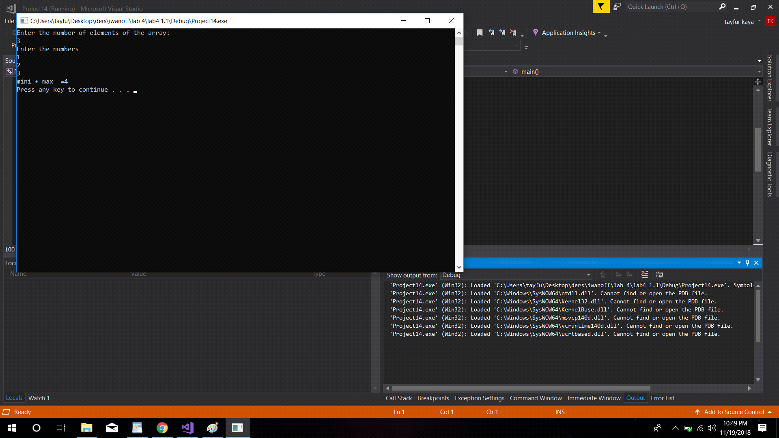

Task 2 : The code

#include <iostream>

using namespace std;

void sortNumbers(int dizi[])

{

int temp;

for (int a = 0; a <= 10; a++)

{

for (int b = 0; b <= 10; b++)

{

if (dizi[b] > dizi[b + 1])

{

temp = dizi[b];

dizi[b] = dizi[b + 1];

dizi[b + 1] = temp;

}

}

}

}

int main()

{

int dizi[10], temp;

for (int i = 0; i <= 10; i++)

{

cout << "enter value=";

cin >> dizi[i];

}

sortNumbers(dizi);

for (int d = 0; d <= 10; d++)

{

cout << dizi[d] << endl;

}

system("pause");

return 0;

}

Task 2: Execution result

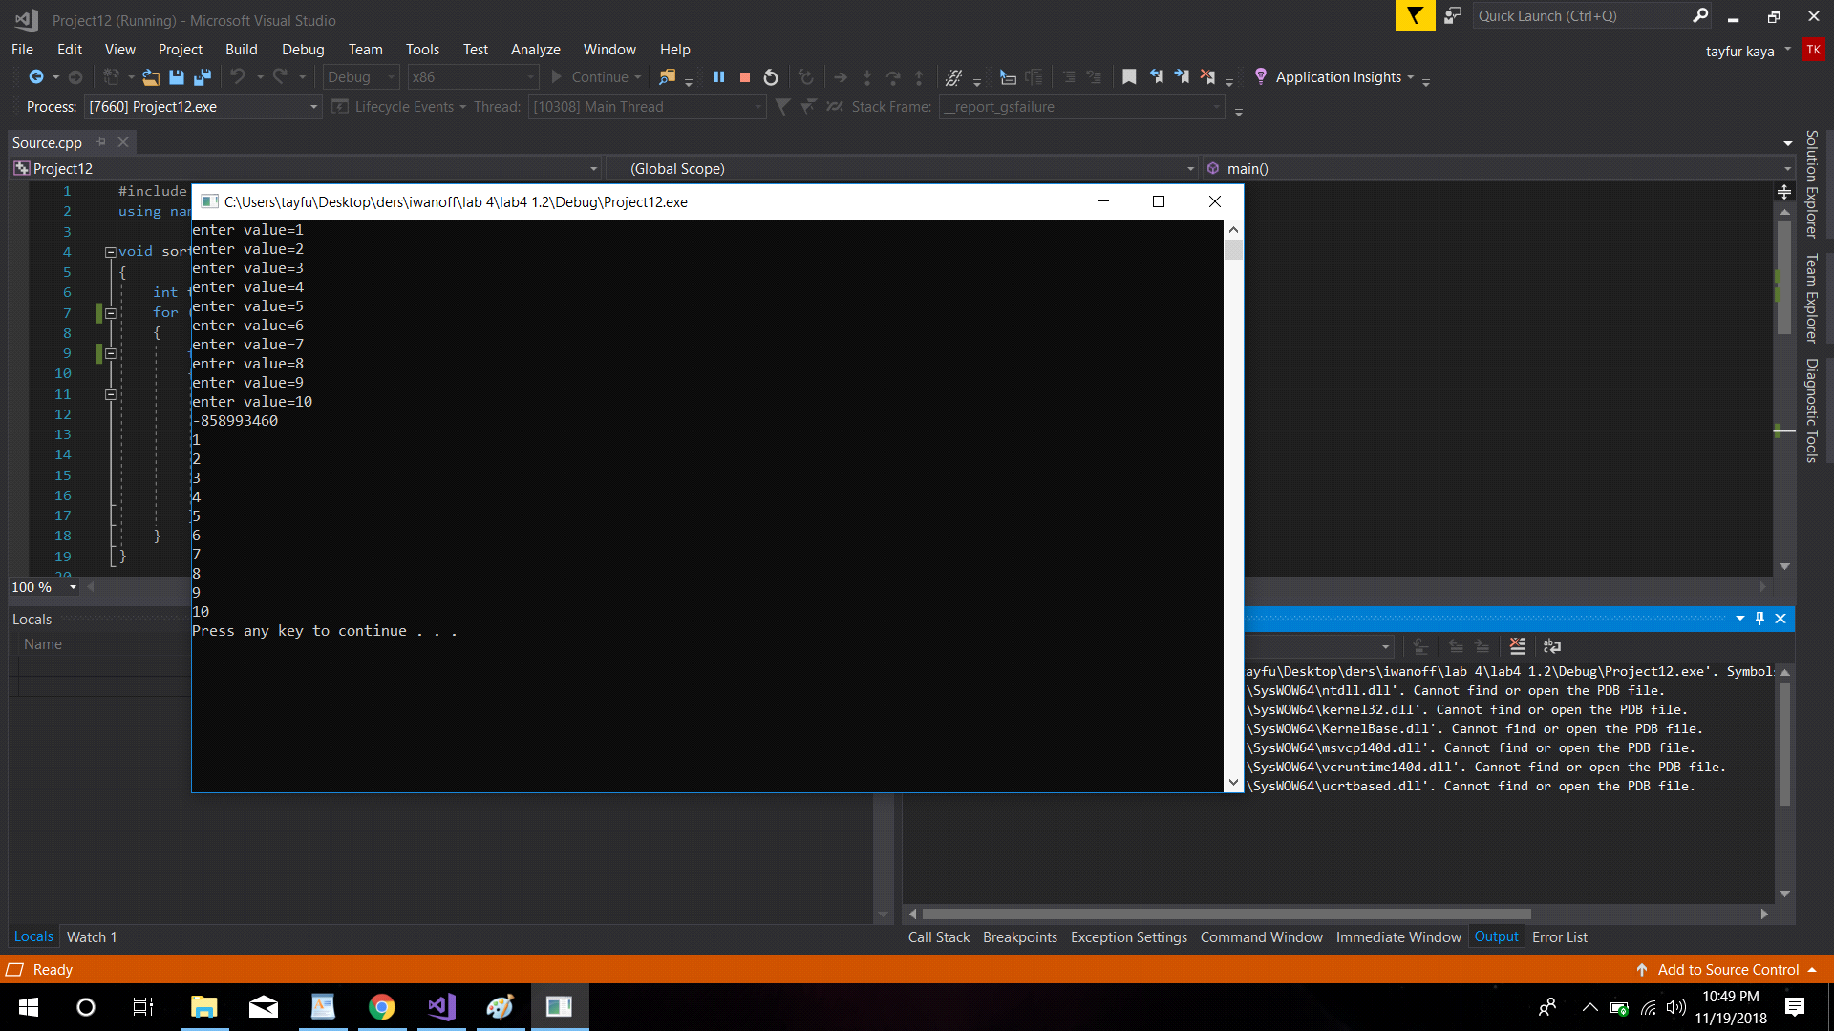

Task 3:

#include<iostream>

using namespace std;

int main()

{

int arr[2][2] = { 2, 3, -4, -5 };

int sum = 0;

for (int i = 0; i < 2; i++)

{

for (int j = 0; j < 2; j++)

{

if (arr[i][j] > 0)

{

sum += arr[i][j];

}

}

}

cout << sum;

system("pause");

return 0;

}

Task 3: Execution result

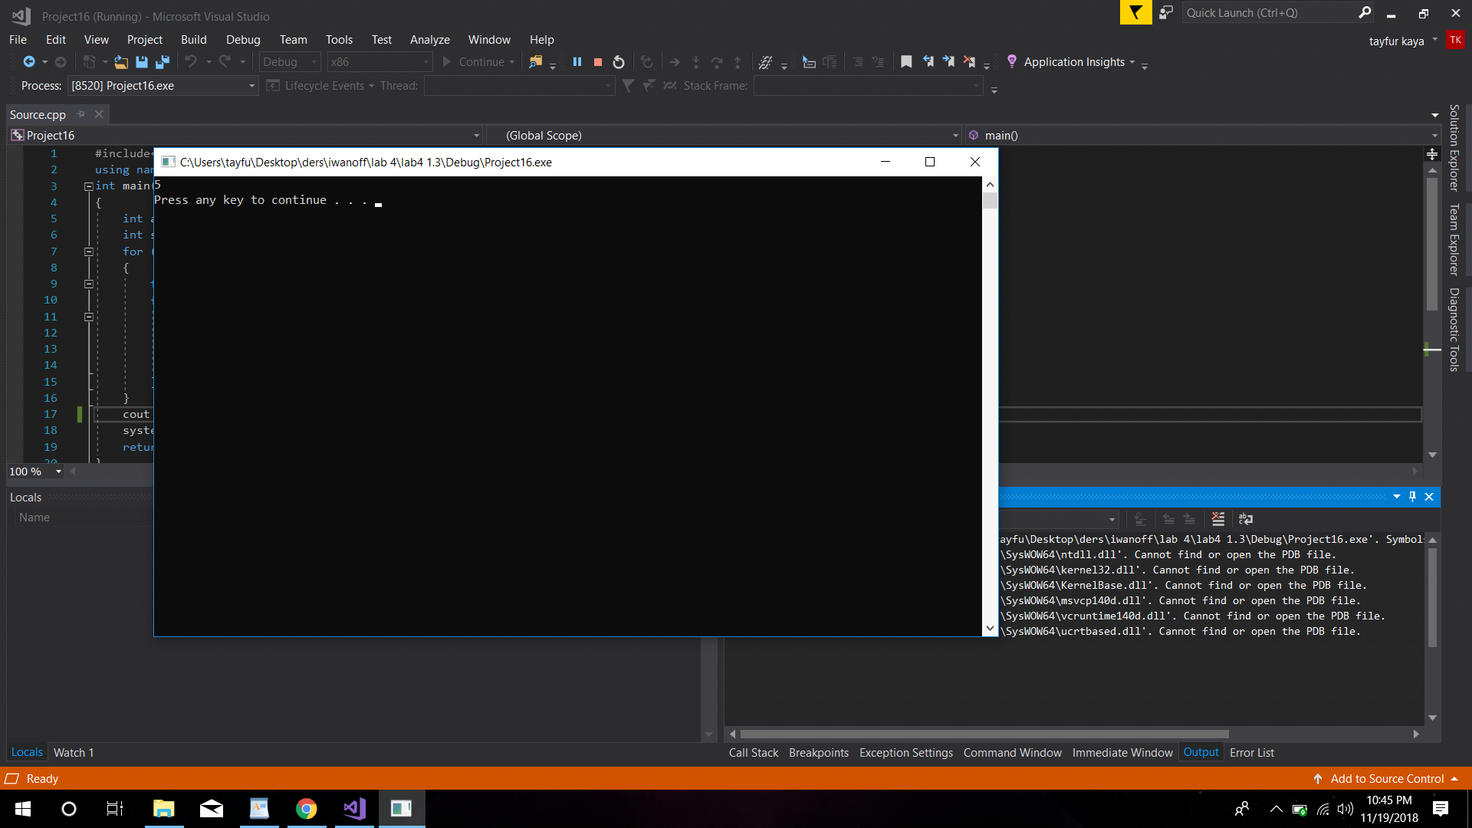

Task 4;

#include <iostream>

using namespace std;

int main()

{

int m, n,sum;

cout << "enter the size of the array :" << endl;

cin >> m >> n;

int i,j;

// 1 2 3

// 4 5 6

// 7 8 9

// 12 14 18

int **a = new int*[m];

for (i = 0; i < m; i++)

{

a[i] = new int[n];

}

cout << "Enter elements of array :" << endl;

for (int i = 0; i < m; i++)

{

for (int j = 0; j < n; j++)

{

cin >> a[i][j];

}

}

cout << endl;

for (int j = 0; j < n; j++)

{

sum = 0;

for (int i = 0; i < n; i++)

{

sum += a[i][j];

}

cout << sum <<" ";

}

system("pause");

return 0;

}

Task 4 Execution result

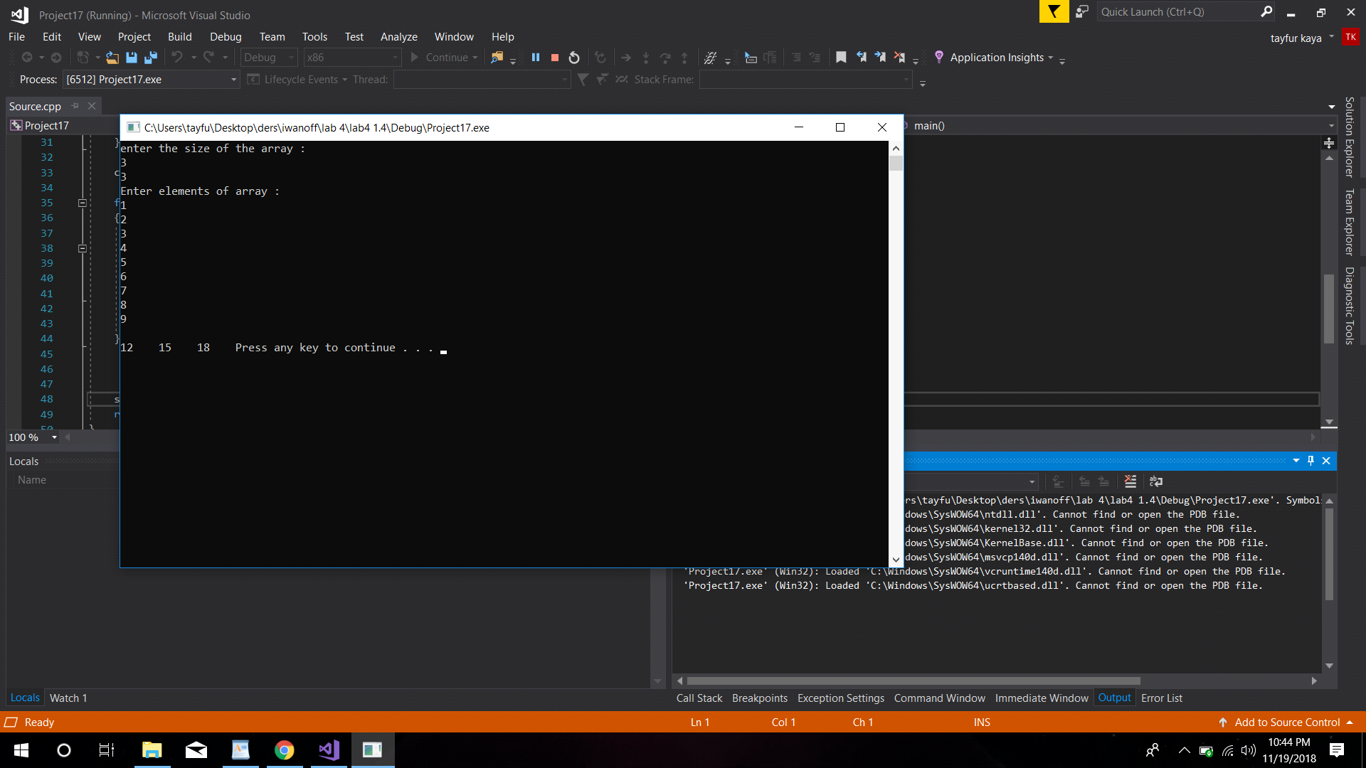

**Individual Assignment**

**The code:**

#include "pch.h"

#include <iostream>

#include <math.h>

using namespace std;

int main()

{

//define two dimension array

int A[4][3];

int totalCol;

// intiate array

cout << "Enter elements of array:" << endl;

for (int i = 0; i < 4; i++)

{

for (int j = 0; j < 3 ;j++)

{

cin >> A[i][j];

}

}

//total cols = rows * cols

totalCol = 4 * 3;

for (int i = 0; i < 4; i++)

{

for (int j = 0; j < 3; j++)

{

if ( ( (A[i][j]) % 2 ) != 0)

{

A[i][j] *= 2;

}

}

}

for (int i = 0; i < totalCol; i++) {

}

int n = 4;

double *roots = new double[n];

int indexOfMin = 0;

for (int i = 0; i < 4; i++)

{

for (int j = 0; j < 3; j++)

{

if (A[i][j] > 0)

{

if ( A[i][indexOfMin] <= 0)

{

indexOfMin = j;

}

if (A[i][j] <= A[i][indexOfMin])

{

indexOfMin = j;

}

}

}

double root = (double) A[i][indexOfMin];

roots[i] = sqrt(root);

}

cout << " \n this are the values of the transformed array : \n";

for (int i = 0; i < 4; i++)

{

for (int j = 0; j < 3; j++)

{

cout << A[i][j] << " ,";

}

}

for (int i = 0; i < 12; i++) {

}

cout << "\n this are the values of the Square roots of minimal positive elements of rows : \n";

for (int i = 0; i < 4; i++)

{

cout << roots[i] << " ,";

}

delete[] roots;

}

